MCKV INSTITUTE OF ENGINEERING

Computer Science and Engineering – Data Science

***Name - Abhinaba Sarkar***

***Roll No. - BTECH/CSE-DS/2020/47***

**Assignment Number: *1***

Problem statement:

Write a program to print MCKVIE and Computer Science & Engineering. Apply \n in your program.

Assignment 1.a)

Source code:

print('MCKVIE \nand Computer Science & Engineering.')

output:

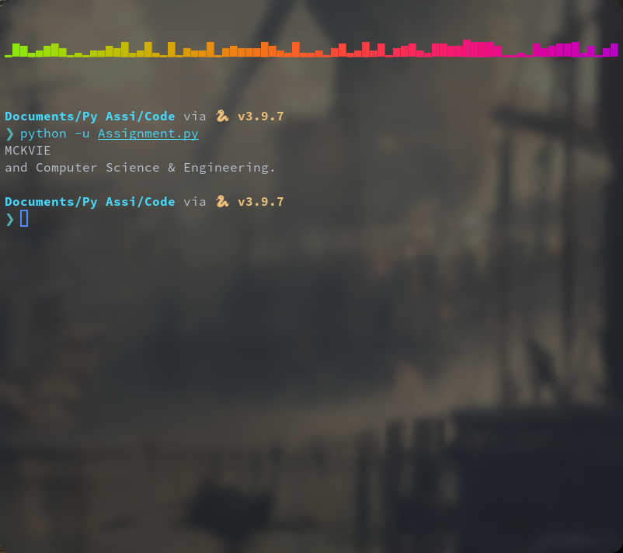

Problem statement:

Consider the radius of a Circle and write a python program to calculate area and perimeter and display the results.

Assignment 1.b)

Source code:

a=float(input("radius="))

area= 3.14*a*a

peri= 2*3.14*a

print("area=",area,",perimeter=",peri)

output:

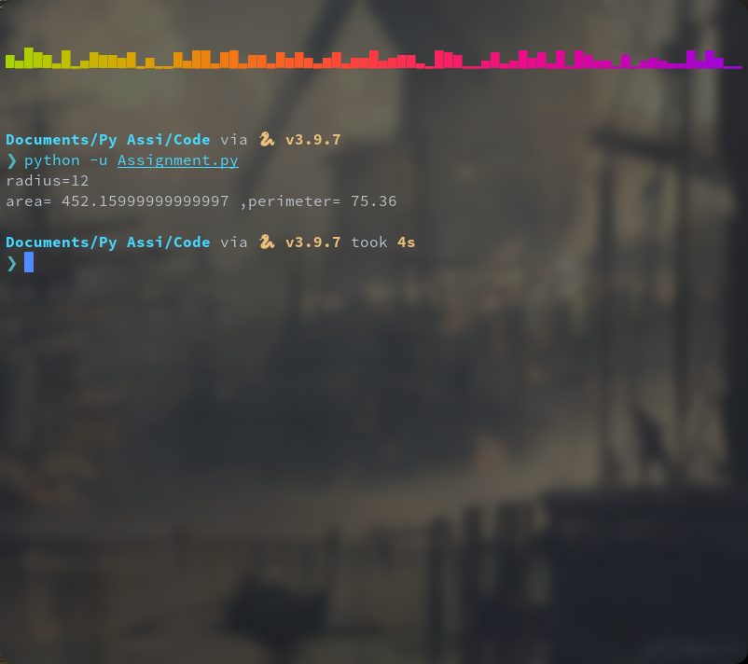

Assignment 1.c)

a=float(input("first no.="))

b=float(input("second no.="))

c=float(input("third no.="))

avg=(a+b+c)/3

print('average= ', avg)

output:

